CASE FILE 08
Pass Lane Driving School
Product line: driver's training packages
Pass Lane is a driving school with locations in the northwest suburbs. Right now every student buys the same package, and Pass Lane is losing customers on both ends.
Your job: Build a lineup of three versions, one for each segment below. For every version, choose its features and set its price. Your goal is the most total profit across all three.
THE MARKET: THREE SEGMENTS
Pass Lane Driving School surveyed people in the Chicago area. The survey split them into three groups. Read the profiles, then give each segment a name.
SEGMENT A  6,000 potential customers | SEGMENT B  1,500 potential customers | SEGMENT C  3,500 potential customers
- Parents of 15-year-olds starting the permit process  - The parent pays, the teen drives  - Worried about their teen driving with friends  “Just get my kid licensed without me panicking in the passenger seat.” | - Adults ages 20 to 35 who never got a license  - Nervous about highways and city traffic  - Works full time during the week  “I'm 26 and I've never driven on the Kennedy.” | - Teens who already practiced plenty with family  - Just need the required minimum and a car for the test  - Paying with their own money  “My dad taught me. I just need a car for the road test.”
Our name for them: | Our name for them: | Our name for them:
PRODUCT BASICS
Base cost of every version | $120 per student, before any features are added
Price options | $225 $300 $375 $475 $600 $750 (each version must use one of these prices)
WARM-UP: READ THE DATA FIRST
1. Which segment has the most must-have features (60% or higher)? How many does it have?

2. What is the most expensive feature on the menu? Which segment, if any, says it is a must-have?

3. What is the lowest price at which fewer than half of Segment B would buy?

4. If Pass Lane Driving School sold a version with a Fit of 100% to Segment A at $375, how many people would buy it?

SURVEY RESULTS: WHAT EACH SEGMENT REQUIRES
Question asked: “Which of these would a driver's training package need to have before you would buy it?”
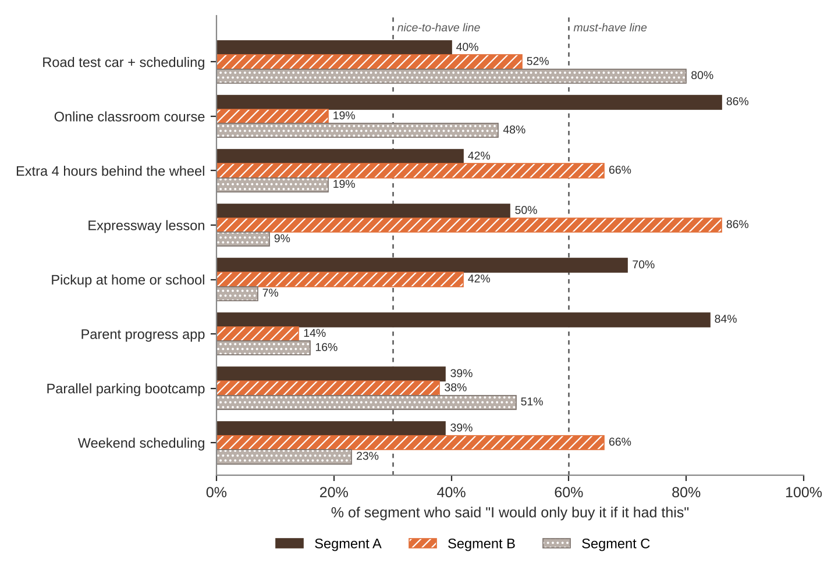
FEATURE MENU
Every feature you add raises your cost per student. Add a feature to any version you want.
Feature | What it is | Cost to add
Road test car + scheduling | We book the test and provide the car | $40
Online classroom course | The required 30-hour course for teens | $25
Extra 4 hours behind the wheel | More practice with an instructor | $110
Expressway lesson | A full lesson on the expressway | $45
Pickup at home or school | Instructor picks the student up | $30
Parent progress app | Parents see lesson notes and scores | $10
Parallel parking bootcamp | One hour of parking practice | $20
Weekend scheduling | Lessons on Saturdays and Sundays | $15
SURVEY RESULTS: WHAT EACH SEGMENT WILL PAY
Question asked: “If it had everything you need, would you buy it at this price?”
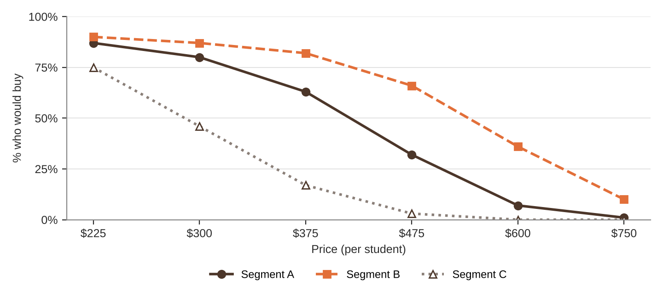
% of each segment who would buy at each price
Price | $225 | $300 | $375 | $475 | $600 | $750
Segment A | 87% | 80% | 63% | 32% | 7% | 1%
Segment B | 90% | 87% | 82% | 66% | 36% | 10%
Segment C | 75% | 46% | 17% | 3% | 0% | 0%
QUICK RULES
Must-have | A feature that 60% or more of a segment requires. Leave one out and that segment's buyers are cut in half. Leave two out and they're cut in half again.
Nice-to-have | A feature that 30% to 59% of a segment requires. Each one you include adds 5% to Fit.
Under 30% | That segment doesn't care. It adds cost and nothing else.
Fit | Start at 100%. Add 5% for each nice-to-have included. Then cut in half for each must-have left out.
Buyers | Segment size × % who would buy at your price × Fit. Round to a whole number.
Profit | Buyers × (Price − Unit cost). Unit cost = base cost + cost of every feature you added.

